NOTE: You must have admin rights to proceed with this Installation, or you can raise an IT Ticket as well for below set up.

1. Install Ubuntu from Microsoft Store
2. 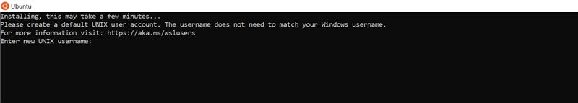
3. Username – “enter your username” Password – “choose password”
4. <https://pureinfotech.com/install-windows-subsystem-linux-2-windows-10/>
5. <https://dev.to/bartr/install-docker-on-windows-subsystem-for-linux-v2-ubuntu-5dl7>
6. For docker compose run “sudo curl -L "<https://github.com/docker/compose/releases/download/1.24.0/docker-compose-$(uname> -s)-$(uname -m)" -o /usr/local/bin/docker-compose”
7. Now you can run docker compose command to run dependencies like below

